2 Q : College Symposium App

1.0 Introduction
1.0 Functional Requirements
College Symposium is a famous App and it provides excellent service to register and manage students. They need to automate the online operations related to student registration and various College information related to contests and reward points.
You need to implement the College and Student module of the online College Symposium App application. The client wishes to have restful web services to add a college and view the college details based on the requirement.
Also, the client wishes to have restful web services for manipulation of Student like, add a student, update the contest result of a student and view the student details based on the requirement.
Help them to automate the above process by developing Rest Service using Maven.
2.0 Technical Specifications
The provided CollegeController and StudentController which are RestController, should be created with the given services:
Services:
CollegeController:
All the below endpoints should return the ResponseEntity
1. For success - HttpStatus.OK
Request Method | Request Url | Description
Post | /addCollege | This service should add the College details by using the addCollege method of the CollegeServiceImpl.
Put | /updateRewardPoints/{collegeId}/{rewardPoints} | This service should update the reward points for the given collegeId using updateRewardPoints method of CollegeServiceImpl.
Get | /viewCollegeByRewardPointsRange/{minLimit}/{maxLimit} | This service should retrieve the colleges with the reward points between the minLimit and maxLimit given using viewCollegeByRewardPointsRange method of CollegeServiceImpl.
Get | /viewCollegeByCityAndCollegeType/{city}/{collegeType} | This service should retrieve the colleges in the given city and with the given college type using viewCollegeByCityAndCollegeType method of CollegeServiceImpl.
Get | /getStudentCountCollegeWise | This service should retrieve the total count of students for each college by using the getStudentCountCollegeWise method of the CollegeServiceImpl.

StudentController:
All the below endpoints should return the ResponseEntity
1. For success - HttpStatus.OK
Request Method | Request Url | Description
Post | /addStudent/{collegeId} | This service takes the Student object and the collegeId of the College object as input and it should add the Student details by using the addStudent method of the StudentServiceImpl.  Note: The Student object holds details like studentId, name, department, activityType, score.
Put | /updateScore/{studentId}/{score} | This service should update the score for the given studentId using updateScore method of StudentServiceImpl.
Get | /viewStudentById/{studentId} | This service should retrieve the existing Student details based on the studentId given by using the viewStudentById method of the StudentServiceImpl.
Get | /viewStudentsByCollegeName/{collegeName} | This service should retrieve the list of existing Student details based on the collegeName by using the viewStudentsByCollegeName method of the StudentServiceImpl.
Delete | /deleteStudent/{studentId} | This service should delete the existing Student detail by using deleteStudent method of the StudentServiceImpl.
Service Layer
Refer to the ICollegeService interface provided as part of the code skeleton. The CollegeServiceImpl which is provided as part of the code skeleton has to realize all the methods in the ICollegeService interface.
Also, the IStudentService interface is provided as part of the code skeleton. The StudentServiceImpl which is provided as part of the code skeleton has to realize all the methods in the IStudentService interface.
In CollegeServiceImpl and StudentServiceImpl classes all database-related operations should be implemented using the CollegeRepository and StudentRepository interface respectively.
Methods in CollegeServiceImpl
Method in Service | Description | Exception
addCollege | This method should add the College object, which contains details like college id, college name, city, college type, and reward points, to the database using CollegeRepository and return that College object.
updateRewardPoints | This method accepts collegeId and rewardPoints as parameters. It should check the availability of the College based on the collegeId, and if the College exists, then update the rewardPoints of that College object with the given rewardPoints passed as parameter in the database using CollegeRepository, and return that updated College object. | If no College exists with that college id then throw InvalidCollegeException
viewCollegeByRewardPointsRange | This method accepts minLimit and maxLimit as arguments. It should retrieve the list of existing College details within the given reward points range (both inclusive) from the database.
viewCollegeByCityAndCollegeType | This method accepts city and college type as argument. It should retrieve the list of colleges with the given city and college type from the database.
getStudentCountCollegeWise | This method retrieves the number of students in each college from the database and should return a Map with key as collegeId and value as the total number of students in that college.

Methods in StudentServiceImpl
Method in Service | Description | Exception
addStudent | This method accepts a Student object that holds details like studentId, name, department, activityType, score and the collegeId. This method should retrieve the College object for the college id passed as parameter.  Next, set that College object to the Student object. Add the Student details to the database using StudentRepository and return the Student object. | If no College exists with that college id, then throw InvalidCollegeException.
updateScore | This method accepts studentId and score as parameters. It should check the availability of the Student based on the studentId, and if the Student exists, then update the score of that Student object by adding the given score to the score of that Student in the database using StudentRepository, and return that updated Student object. | If no Student exists with that studentId, then throw an InvalidStudentException
viewStudentById | This method accepts a studentId as parameter. It should retrieve the Student details with the given studentId from the database. | If no Student exists with that studentId then throw InvalidStudentException
viewStudentsByCollegeName | This method accepts college name as argument. It should retrieve the list of Students who belong to that College.
deleteStudent | This method accepts a studentId as argument. It should delete the Student object with the given studentId from the database. | If no Student exists with that studentId then throw InvalidStudentException

Repository Layer
Refer to the CollegeRepository and StudentRepository interfaces provided as part of the code skeleton. Use appropriate Spring Data JPA methods for all database-related manipulations.
Also include the necessary methods in CollegeRepository to view Colleges by reward points between a given range, to view college based on a given city and college type and to getStudentCountCollegeWise. StudentRepository includes the necessary methods to view Students based on a given college name.
Model
Refer to the Model class provided as part of the code skeleton and use appropriate annotations for the persistence mapping in the model class.
Model Class - College
Refer to the College and Student class provided as part of the code skeleton, use appropriate annotations to generate getter/setter and use an all-argument constructor.
College class
Attribute | Data Type
collegeId | String
collegeName | String
city | String
collegeType | String
rewardPoints | int
studentList | List<Student>

Student class
Attribute | Data Type
studentId | String
name | String
department | String
activityType | String
score | int
collegeObj | College

Note:
Use Lombok to generate getters and setters for the attributes
Also generate all-argument constructor using lombok
Do not change the datatype or the attribute name provided as part of the code skeleton
Business Validation
Inbuilt Validation
Rule | Message when validation fails
collegeId should not be empty | Provide value for college id
collegeName should not be empty | Provide value for college name
city should not be empty | Provide value for city
collegeType should not be empty | Provide value for college type
rewardPoints should be between 0 and 10 | Reward points should be between 0 and 10

Rule | Message when validation fails
studentId should not be empty | Provide value for student id
name should not be empty | Provide value for name
department should not be empty | Provide value for department
activityType should not be empty | Provide value for activity type
score should be greater than or equal to zero | Score should be greater than or equal to zero
Perform the above Validations using annotations that are available in jakarta.validation.constraints package
Incorporate Exception and validations as ResponseEntity
To incorporate the messages related to Exception and validations (both custom and inbuilt validations) as ResponseEntity, you are provided with the following classes.
ExceptionResponse class that represents what attributes needs to be there in the customized response error message. Make use of this class to send the customized response error message.
CustomizedResponseEntityExceptionHandler class to handle all the exceptions that has occurred in the application (both user-defined and pre-defined).
Method Name | Explanation
handleAllExceptions | This method should generally handle all the exceptions.  In ResponseEntity set the HTTPStatus as INTERNAL_SERVER_ERROR.
handleNotFoundException | This method should handle and provide customized error message using Exception Response class for user defined exception InvalidCollegeException and InvalidStudentException  In ResponseEntity set the HTTPStatus as NOT_FOUND.
handleMethodArgumentNotValid | This method should handle and provide customized error message using Exception Response class for both pre-defined and user defined validations.  In ResponseEntity set the HTTPStatus as BAD_REQUEST.

Expected Table Structure
The given table should get created automatically by the application
Note
- Provide the necessary annotation in the model classes so that the column size for String fields is set to the size mentioned in the below schema diagrams.
College
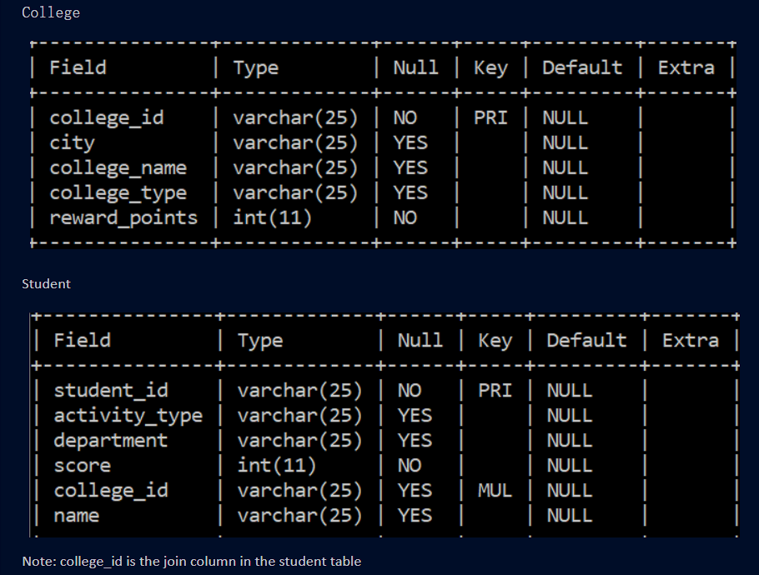

Note: college_id is the join column in the student table
4.0 Process Flow
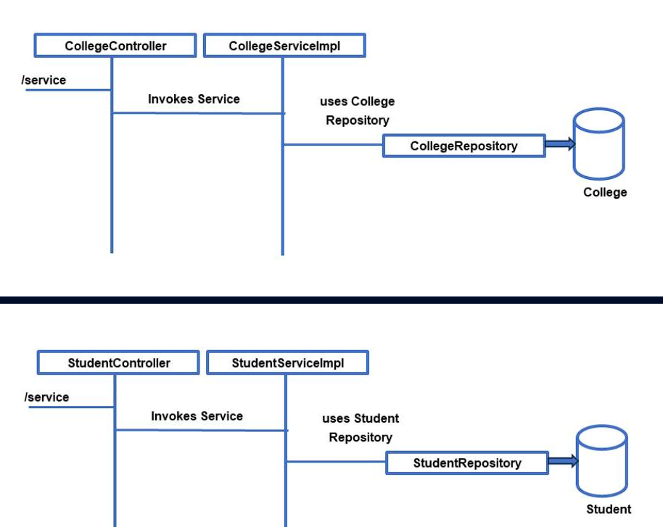
- Client invokes the required service.
- CollegeController invokes the method of the CollegeServiceImpl and StudentController invokes the method of the StudentServiceImpl
- CollegeServiceImpl with the help of CollegeRepository performs the service and returns the data back
- StudentServiceImpl with the help of StudentRepository performs the service and returns the data back
- ICollegeService has to be injected into the CollegeController
- CollegeRepository has to be injected into the CollegeServiceImpl
- IStudentService has to be injected into the StudentController
- StudentRepository has to be injected into the StudentServiceImpl
- The CollegeRepository interface and StudentRepository interface should use the appropriate Spring Data JPA for all the database-related manipulation.
4.0 Overall Design Constraints
1) Do not change the property and value given in the application.properties files. If needed you can change the value of username and password alone according to what you have in your MYSQL
2) In the pom.xml you are provided with all the dependencies needed for developing the application.
3) Use only Spring data JPA to handle persistence. Do not generate value for the primary key attribute automatically.
4) Use the service type and the service names as expected in the specification
5) Adhere to the design specifications mentioned in the case study.
6) Do not change or delete the class/method names or return types which are provided to you as a part of the base code skeleton.
7) Please make sure that your code does not have any compilation errors while submitting your case study solution.

